

* Program Book

**Community Service Project**

**AP STATE COUNCIL OF HIGHER EDUCATION**

**(A STATUTORY BODY OF GOVERNMENT OF ANDHRA PRADESH**

**Program Book for**

**Community Service Project**

**Name of the Student: B. PAVAN KUMAR REDDY**

**T. SUNIL KUMAR**

**A. UDAY KIRAN RAJU**

**M.RAJAVARDHAN NAIDU**

**M.NARESH**

**Name of the College:** JAWAHARLAL NEHRU TECHNOLOGICAL UNIVERSITY ANANTAPUR

(AUTONOUMOUS) COLLEGE OF ENGINEERING ANANTAPUR

**Registration Number:**



**Period of CSP: From:15-09-2022 To: Name & Address of the Community/Habitation:**

BUKKARYASAMUDRAM, ANANTAPUR

PIN CODE:515701

**Community Service Project Report**

*Submitted in accordance with the requirement for the degree of*

*B. TECH.*



Name of the College: j



Department:

Name of the Faculty Guide: Dr. S. Sharada

Duration of the CSP: From 15-09-2022 To 25-10-2022

Name of the Student: **B. PAVAN KUMAR REDDY**

**T. SUNIL KUMAR**

**A. UDAY KIRAN RAJU**

**M.RAJAVARDHAN NAIDU**

**M.NARESH**



Programme of Study Year of Study: Register Number: 

Date of Submission:

# Student’s Declaration

I B. PAVAN KUMAR REDDY, a student of III B. Tech Program, Reg. No.20001A0802 of the Department of CHEMICAL ENGINEERING,JNTUACEA College do hereby declare that I have completed the mandatory community service from15-09-2022 To 25-10-2022 in Bukkarayasamudram Anantapur under the Faculty Guideship of

Dr. S. Sharada Department of Chemical Engineering in JNTUACEA.

(Signature and Date)

# Endorsements

Faculty Guide: Dr. S. Sharada

Head of the Department:Dr. B. DILIP KUMAR

Principal: Dr. P. Sujatha

# Student’s Declaration

I T. SUNIL KUMAR, a student of III B. Tech Program, Reg. No.20001A0816 of the Department of CHEMICAL ENGINEERING, JNTUACEA College do hereby declare that I have completed the mandatory community service from15-09-2022 To 25-10-2022 in Bukkarayasamudram Anantapur under the Faculty Guideship of

Dr. S. Sharada Department of Chemical Engineering in JNTUACEA.

(Signature and Date)

# Endorsements

Faculty Guide: Dr. S. Sharada

Head of the Department:Dr. B. DILIP KUMAR

Principal: Dr. P. Sujatha

# Student’s Declaration

I A. UDAY KIRN RAJU , a student of III B. Tech Program, Reg. No.20001A0832 of the Department of CHEMICAL ENGINEERING, JNTUACEA College do hereby declare that I have completed the mandatory community service from15-09-2022 To 25-10-2022 in Bukkarayasamudram Anantapur under the Faculty Guideship of

Dr. S. Sharada Department of Chemical Engineering in JNTUACEA.

(Signature and Date)

# Endorsements

Faculty Guide: Dr. S. Sharada

Head of the Department:Dr. B. DILIP KUMAR

Principal: Dr. P. Sujatha

# Student’s Declaration

I M.NARESH , a student of III B. Tech Program, Reg. No.20001A0862 of the Department of CHEMICAL ENGINEERING,JNTUACEA College do hereby declare that I have completed the mandatory community service from15-09-2022 To 25-10-2022 in Bukkarayasamudram Anantapur under the Faculty Guideship of

Dr. S. Sharada Department of Chemical Engineering in JNTUACEA.

(Signature and Date)

# Endorsements

Faculty Guide: Dr. S. Sharada

Head of the Department: Dr. B. DILIP KUMAR

Principal: Dr. P. Sujatha

# Certificate from Official of the Community

This is to certify that  **B. PAVAN KUMAR REDDY, T. SUNIL KUMAR, A. UDAY KIRAN RAJU, M. RAJAVARDHAN NAIDU, M. NARESH** Reg. No 20001A0802, 20001A0816, 20001A0832, 20001A0846, 20001A0862 of JNTUACEA underwent community service in BUKKARAYA SAMUDRAM from 15-09-2022 to 25-10-2022

The overall performance of the Community Service Volunteer during them community service is found to be GOOD.

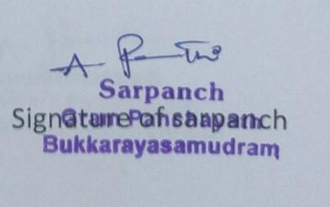

Authorized Signatory with Date and Seal

**ACKNOWLEGEMENTS**

We sincerely thank our Mentor **Dr. S. SHARADA**, Associate professor Department of Chemical Engineering, JNTUCEA for all the help and guidance given to us during the course of completing my Community Service Program as a part of III Year I Sem, curriculum especially we thank our Head of the department **Dr. B. DILIP KUMAR** for the necessary inputs and keen interest in making us go forward with this program.

We also express our gratitude to **J. SUMANGALI** Principal Z.P.H. S high school Bukkarayasamudram and teacher **G. DIWAKAR** sir for helping us in conducting awareness in school and also, we thank to Bukkarayasamudram mandal Sarpanch **A. PARVATHI** for helping us in conducting Community service project and we thank to the villagers for providing the support that is required.

We also thank the respondents of our Community Service Project and our families & friends for their contribution.

**Date: Name of the student: B. PAVAN KUMAR REDDY**

**Place: Signature of the student:**

**CHAPTER 1: EXECUTIVE SUMMARY**

“HEALTH AND NUTRITION”

in Bukkarayasamudram mandal Anantapur district.

Community service project is an experimental learning strategy that consists of participation, learning and community development. Community service project involves students in community development and service activities and applies the experience to personal and academic development. Community service is unpaid work performed by a person for the betterment of the community without any form of compensation.

Community service project is meant to link the community with the college for mutual benefit. The community will be benefited with the focused contribution of the college students for local development. The college finds an opportunity to develop social sensibility and responsibility among students and also emerge as a socially responsibility institution.

**Objectives of Community Service Program:**

* To conduct socio economic survey in the community.
* To study the nutrition provided for school children during mid-day meals provided by Govt. schools of A.P
* To study the nutrition provided to children below age of 5 years in Anganwadi schools.
* To conduct survey in Govt. hospitals and enquiring the doctors about the necessary nutrients required for the human body for the healthy growth.
* To conduct the awareness programme on nutrition in schools.

**CHAPTER 2: OVERVIEW OF THE COMMUNITY**

Bukkarayasamudaram is a village and Mandal in Anantapur bukkarayasamudram population in 2022 is estimated 24640. According to 2011 census total population 21560 males-10134, female -10966, household-5220. The total geographical area of village is 3536 hectares. Literacy rate of bukkarayasamudram 53.75 percentage out of which 59.96 percentage males and 49 percentage females are literate. There are 3220 houses in bukkarayasamudram. Anantapur is the nearest town of town to bukkarayasamudram for all major activities, approximately 4km away. Anantapur got its name from "Ananta sagaram" a big tank, which means endless ocean.

The villages of ananta Sagaram and bukkarayasamudram were constructed by Anantarayas Chillkkavodeya, the Minister of bukka-1 a Vijayanagaram ruler Bukkarayasamudram-1(resigned(1356-1377CE) was an emperor vijayanagar empire sangama dynasty. He was a son of bhavana sangama. Even with the wars and internal conflicts, bukka still managed to help support with the internal improvements for the city, important works of literature were also written doing his rule

It is excited during regin of Vijayanagara empire, which was named after Ananthamma wife of Bukkaraya one of the founders of Empire.

In bukkarayasamudram there is a temple of where the lord Venkateswara is in the small rock. It is like a tourist place in the village where Lord Venkateswara came (swayambhu) self manufested rock. That temple is famous known as konda Meda Venkatramana swami. In olden days people calls chervu katta.

Villages in bukkarayasamudram mandal

1. Bodaiganidodi

2.bukkarayyasamudram

3.chedulla

4.chennampalle

5 chennarayunipalle

6.danduvarupalle

**CHAPTER 3: COMMUNITY SERVICE PART**

In this community service project we take in the permission from A. Parvathi sarpanch of bukkarayasamudram Mandal. After taking the permission we immediately went to the school and we participated in activities that are held in primary school and as well as in high school. In high school every day they will provide food for the students which is good for health mid-day meal added by CM Chandrababu Naidu and it is continued by Present CM also Jagan Mohan Reddy garu. According to menu they will provide egg daily except Saturday and rice sambar combination we interacted the people Diwakar sir in high school math teacher. Sir helped a lot and saying about nutrition for thir student a line he said to the student that "ANNAM PARABRAHAMA SWAROOPAM".

Next day we surveyed different generation and different people about their health nutrition the first person Rama Reddy his 81 years now also he is fit and doing works himself. In his early days daily he used to eat millets grains food which were prepared in pots, food which were prepared in pots ganji Annam. He used to take food two times a day and he had no problem nothing. Next we survey Y.Subba Reddy 48 years and he had one daughter and one son. He is from Anantapur and he suffering from leg pain due to dehydration and sometimes due to improper food. In this survey we conclude that the whose age is 70-80 they are fit and their nutrition is so healthy.

The next day we visit at the primary school to participate in awareness program on NULU PURUGULA tablet.. We explain the children what is the use of tablet. NULU PURUGULA tablet is also known as ALBENDAZOLE. It is ANTHELMINTIC or ANTI-WORM medication. It prevents the formation of insect larvae and growing in our body.It is used to treat infections caused by worms such as per tape worm.

Evening we conducted awareness program on career guidance to the youngster’s from 10th in High School Bukkarayasamudram. Here Diwakar sir cooperated a lot to conduct a class and that is helpful to their students. Our group interacted with the students and make the fun sometimes, after that we gave lecture class about career guidance for the 10th class students. We aquired life skills on how to talk with strangers and how to behave with them.

| **ACTIVITY LOG FOR THE FIRST WEEK** | | | |
| --- | --- | --- | --- |
| **DAY**  **& DATE** | **BRIEF DESCRIPTION OF THE DAILY ACTIVITY** | **LEARNING OUTCOME** | **Person In-charge Signature** |
| **15-09-2022**  **Thursday** | Meeting with government officials and visiting grama sachivalayam of bukkarayasamudram and collecting data regarding the population, literacy rate, sex ratio, geographical area and taking permission to conduct CSP project. | we learnt about how to interact with government officials. |  |
| **16-09-2022**  **Friday** | Meeting with sarpanch and asking permission by submitting permission letter to conduct CSP project in their village, and enquiring about the demographics of the village. Questioning the sarpanch about the problems faced by villagers and actions taken by government to address these problems. | We learnt about the solutions made by the sarpanch to those problems in the difficulty time also. |  |
| **17-09-2022**  **Saturday** | Meeting the villagers and asking them few questions about their lives and experiences in village. These questions are from standardized questioner so we can compare results from one person to another and studying the outcome | We learnt about the different life styles of villagers by interacting with them. |  |
| **19-09-2022**  **Monday** | Visiting the primary health care center of bukkarayasamudram and enquiring about the health conditions of the villagers and his experiences while working in that village. | We are capable to understand the health conditions of the villagers by the results of the primary health care centre. |  |
| **20-09-2022**  **Tuesday** | Visiting the nearby anganwadi, and asking them about number of children and pregnancy women present in their anganwadi, and also enquiring about the nutrition provided through food provided to children and pregnancy women in anganwadi. | We are able understand the different types of nutrients provided to the child in their small age. |  |
| **21-09-2022**  **Wednesday** | Visiting primary school and zilla parishad high school and asking permissions from the principals of the schools and enquiring about the strength of the students and faculty present in the schools. | We can see the lot of difference between the present and olden days by seeing the strength of the students and the quality of education. |  |

**WEEKLY REPORT**

**WEEK – 1 (From Dt 15-9-2022 to Dt 21-09-2022)-**

| **Objective of the Activity Done:** To conduct Socio Economic survey of the habitation |
| --- |
| **Detailed Report**: First day we met the officials of grama sachivalayam and collected the |
| data. The total population of that village is 24000 people, in that male population is |
| 12500, female population is 11500 and sex ratio is about 1:1 ratio. The literacy rate is |
| about 62% in which most literacy rate belongs to men. The geographical area of that |
| village is up to 3536 hectares. The land covered by water in that Village is approximately |
| 100 acres. And about different kinds of religion People live in that village like Hindu, |
| Muslim, Christian. At last, we asked permission to do CSP project and their support while |
| doing the project. Second day of this week we met with sarpanch named **A. PARVATHI** and |
| asked permission for doing CSP project and enquired about the problems in that village |
| she said there is no problems in that village but the only problem was that there was no |
| idea about the health issues facing by them now a days. Minorly there was problem on |
| drainage issue but it was solved, now there is no problems facing by the villagers and |
| asked some questions from the questionnaire. Also asked about the schemes offered by the government. |
| Third day we met with the villagers of that area and we asked about their problems facing in that area by |
| following the questionnaire. And also, we enquired about the health conditions of that people. By the data |
| given by the people we observed that many of the people are facing with blood pressure and diabetics. |
| These problems are mainly observed in below 30 aged people. We observed a child of age 15 years |
| suffering with heart problem by listening that point we felt very sad. Fourth day we visited primary health care center of that village, we met with the doctor of that hospital they received us in a good manner. We enquired about the health conditions of the people in their words. He explained about major problems in that village. For some time, we interacted with the nurse also. On fifth and sixth day we met with the children in anganwadi, primary school, ZPHS school by taking the permissions from the respective departments. We asked about the food providing by government for those people. The head master of ZPHS school spented her time with us and asked about CSP program, and our studies in JNTUACEA. |
| At last we decided to do project on health and nutrition in the area of bukkarayasamudram. |

**ACTIVITY LOG FOR THE SECOND WEEK**

| **DAY**  **& DATE** | **BRIEF DESCRIPTION OF THE DAILY ACTIVITY** | **LEARNING OUTCOME** | **Person In-charge Signature** |
| --- | --- | --- | --- |
| **22-09-2022**  **Thursday** | Visiting the primary school of bukkarayasamudram and talking to children about mid-day meals program. Observing the preparation of different kinds food and overseeing the distribution of food to the children. | We are capable to gather the information about the food provided by the government to the students in mid-day meals. |  |
| **23-09-2022**  **Friday** | Visiting the zilla parishad high school of bukkarayasamudram and talking to students about mid-day meals program. Monitoring the nutrients provided to children through food items by the school through mid-day meals program. | We are able to understand the different nutrients required for the children based on their age. |  |
| **24-09-2022Saturday** | We Participated in a medical camp named “NULI PURUGULA NIVARANA DIN OTSAVAM” which aims to provide tablets to children to avoid white germs in stomach, and teaching about the significance of this program to the children. | We came to the significance of that tablets and how it attacks on the worms in the stomach. |  |
| **26-09-2022Monday** | Visiting the anganwadi and enquiring the pregnant women about the food provided to them and asking to anganwadi teacher about the guidelines set by the government regarding the nutrition provided to children. | We gained the knowledge about what kind of food should be eaten by the pregnant women to maintain good health to the child and herself. |  |
| **27-09-2022Tuesday** | Meeting with ASHA WORKER(ANM) and receiving the information about health condition of the children in village, and also about the various programs conducted by ASHA workers for children like (polio drop and vaccinations for children) | We came to know the importance of the ASHA worker for the society. |  |
| **28-09-2022Wednesday** | Meeting the doctor in primary health care center and enquiring about the necessary nutrition for the healthy growth of children and asking about the health problems frequently faced by children due to various conditions and about the preventive measures to be taken to prevent this. | We are able to gain the knowledge about what kind of nutrients required to grow the child in a healthy manner. |  |

**WEEKLY REPORT**

**WEEK – 2 (From Dt 22-09-2022 to Dt 28-09-2022)**

| **Objective of the Activity Done:** To visit primary school and high school in the habitation and meeting health officials. |
| --- |
| **Detailed Report:** In this week we primarily focused on aquiring information about |
| the nutrition provided to the children of different age groups and different background people in different  school we also visited the hospitals and medical camps and we got professional advice from people |
| Of medical field. On first day we visited the primary school in kottalapalli bukkarayasamudram the exterior structure of the building is under construction and a lot of renovating work is going on |
| here there is no cooking facility available here, the food provided to the children is prepared by ISKON  foundation and the food is distributed by the faculty of the school, 2 teachers are stationed here for taking |
| Care of children, the total strength of the school is 30 children only. The menu items included rice and sambar with a boiled egg rice is of good quality and sambar tasted good and egg is important source of  Nutrition. |
| Next day we visited Zilla parishad high school and observed their mid-day meal program we have been |
| Told by the principle of Z.P.H. SCHOOL Bukkarayasamudram that nearly 800 students consume food during mid-day meal program we observed that here there is a giant food preparation facility here |
| the school also has a residential campus for both girls and boys. The school is located in a large campus area we a huge amount of space for sports activities, all buildings are modern. |
| Mid-day meals are provided at 12clock for all the children. The menu of the mid-day meal is changes from day to day. |
| The next day we visit at the primary school to participate in awareness program on NULU PURUGULA tablet. |
| We explain the children what is the use of tablet. NULU PURUGULA tablet is also known as ALBENDAZOLE. It is ANTHELMINTIC or ANTI-WORM medication. |
| It prevents the formation of insect larvae and growing in our body. It is used to treat infections caused by worms such as per tape worm. Next day we visited nearby anganwadi and observing and interviewing the |
| children’s parents and pregnant women about the food provided by anganwadi and care taken by them. From our interviews we came to know that every day food is prepared in house in anganwadi the food |
| is mostly in semi liquid state with nutritious value because children tend to eat such type of food very easily and everyone are provided with one egg. |
| Next two days we worked with health officials first day we talked with ground level officials ANM s and we asked about the frequent problems faced by the villagers and about their work and actions and taken |
| to improve the nutrition and health conditions of the village. Next day we visited the Primary health care center and we meet the doctor and we asked about the necessary nutrients necessary for the healthy |
| growth of children and major health problems faced by the people. |

**ACTIVITY LOG FOR THE THIRD WEEK**

| **DAY**  **& DATE** | **BRIEF DESCRIPTION OF THE DAILY ACTIVITY** | **LEARNING OUTCOME** | **Person In-charge Signature** |
| --- | --- | --- | --- |
| **29-09-2022**  **Thursday** | We Interviewed among the villagers above the age of 60-90 years (born before 1960) about their eating habits in their young ages and changes they observed during their course of life in food habits, and also asked about their health conditions. | We acquired the information about the life styles of the centenarians. |  |
| **30-09-2022**  **Friday** | We Interviewed among the villagers above the age of 40 years and below the age of 50(born after 1970 and before 1980) about their eating habits in their young ages and the change they observed during their course of life in food habits, and also asked about their health conditions. | We gathered the statistics about the health problems facing by them as they compared with their parents. |  |
| **01-10-2022**  **Saturday** | We Interviewed among the villagers above the age of 20 years and below age of 30(born after 1990) about their eating habits, and then we asked about their health conditions and their work life. | we are able to differentiate between recent health conditions with ancient people health conditions. |  |
| **03-10-2022**  **Monday** | We conducted a group discussion with the people of three different age groups along with them we also participated and expressed our food habits and we tried to analyze the changes that are occurred over these decades in our food habits. | By this program we can able to aware about the need of health and nutrition and taking some real examples among them. |  |
| **04-10-2022**  **Tuesday** | By analyzing the data, we collected from our interviews and group discussions we conducted awareness campaign among the villagers about the nutrition our traditional foods habits contain, how our food habits changed, how our health, life expectancy is declined and how we can improve our health condition. | We learnt about how to share knowledge to the public by taking examples to understand for them. |  |

**WEEKLY REPORT**

**WEEK –3 (From Dt 29-09-2022 to Dt 4-10-2022)**

| **Objective of the Activity Done:** To conduct interviews among villagers of different age groups. |
| --- |
| **Detailed Report:** In this week we interviewed different generations people in the village |
| about their nutrition and their health and conditions First we interviewed RAMA REDDY |
| person in the village and his age 82 years. when he was 20 years his nutrition he wants to eat two times a |
| day. Millet grains, curd rice, cooking in pots and he works daily in his land and he cultivates rice, |
| groundnut, paddy. No health issues an d no diseases and he is so fit and strong. **Millet grains** is a good |
| source as protein, fiber, key vitamins and minerals. The potential health benefits of millet protecting |
| CARDIOVASCULAR health preventing the on set diabetes helping people achieve and maintain a |
| healthy weight and managing inflammation in the gut. Millet grains provides more Energy to work active |
| in our fields. In that days they will eat two times a day. But now a days people will eat three times a day. |
| Like that we interviewed **M.thipanna** about their nutrition and his age 73 years and he also eats two |
| times a day. On 13th day we interviewed old people in the village who are above 60years.we asked them |
| about their nutrition.people in the village what are saying about their nutrition.in a day they want to eat |
| only twice a day.in that days they diet was severals of millets ,grains daily two times a day. |
| We interviewed 5people in a day. Everyone's mind overloading about millets and grains are provides more |
| | energy,health this leads more strength in older days. As for the present we are facing problems by junk | | --- | | Foods. The next day we interviewed 40 to 50 years people. The people 42 to 50 years interviewed about their | | health and food habits. They gave a valid reason about their availability of food and quality of food, nowadays | | that total change due revolutionary among all the fields all evolving about fast growth up all the fields this leads | | many bi-products,which affects more. One of person in older people they share current situation he injured but | | he work on field daily maintain a problem nutrition for his health. Another day we interviewed young people | |
| who are more energetic there are busy with their mobiles and day before there life style totally different. |
| from now revolutionary things happen so all are changed due to conditions in the world, availabilities |
| leads a lazy person. all are fast life with fast foods they do their work relatively from homes and fields but |
| in the adulteration world all are systematic to their profits. |

**ACTIVITY LOG FOR THE FOURTH WEEK**

| **DAY**  **& DATE** | **BRIEF DESCRIPTION OF THE DAILY ACTIVITY** | **LEARNING OUTCOME** | **Person In-charge Signature** |
| --- | --- | --- | --- |
| **7-10-2022**  **Friday** | We Visited primary School and Congregated the Students of 5th Class people to Conduct an awareness program on health and nutrition. About the nutrition levels of that aged people, what kind of food Should we eat in daily life and giving proper explanation about nutrition (like types Carbohydrates, fats, vitamins, minerals) | This awareness program has enhanced our communication skills. |  |
| **08-10-2022**  **Saturday** | We Visited bukkarayasamudram village and we gathered the women of that village and gave an awareness on health and Nutrition, importance of health in daily life and Impact of women health on next generation people. | We came to know that the women are trying to develop the child growth by knowing the information from us. |  |
| **10-10-2022**  **Monday** | We visited Zilla parishad high school and gave an awareness on health and nutrition for eighth class people by explaining about what is meant by health and significance of health in day-to-day life including nutrition and what will happen if nutrition is deficient. | From this awareness program, we are able to compare between the present habitation with ancient days. |  |
| **11-10-2022**  **Tuesday** | we visited Zilla parishad high school and gathered 9th and 10th class students and we conducted a meeting about career guidance like what are the courses available after 10th class and explaining about different groups at 11th standard and we explained about the career in that ideal course. | We are able to grab their intensions about they want to become in their future, and also, we are able to show the right path for their career. |  |

**WEEKLY REPORT**

**WEEK – 4(From Dt 7-10-2022 to Dt 11-10-2022)**

| **Objective of the Activity Done:** To conduct awareness program among school children and villagers |
| --- |
| **Detailed Report:** In the fourth week, first day we visited primary school and |
| congregated the fifth-class students to give an awareness program about health and nutrition, most of the |
| children used to eat junk food which are not healthy food to human.so we suggested to eat good food |
| Which are home made and that food will give more nutrients to the body.as they are children so we said |
| Only some main points in health and nutrition. Second day we visited bukkarayasamudram and we |
| Gathered some women of different ages first we gave a speech about women empowerment like how |
| Women are working now-a-days without any discrimination after that we said about what kind of food |
| Should be taken to maintain a good health and we compared the health conditions of old aged people with |
| them by taking the examples of their relatives who are older. Third day we visited zilla parishad high |
| school of bukkarayasamudram and with the help of staff members we gathered eight class people in one |
| room. Nearly there are 75 students studying there eight standard. As they are grown up, we gave an |
| awareness program in depth. Firstly, we started with the what kind of food they are eating and explained |
| about the nutrient values present in that food. Mainly we suggested to the students that not to neglect |
| about nutrients needed for the human body and we explained about this health with real examples which |
| the world is facing. Fourth day also we visited zilla parishad school only to meet the students of ninth and |
| Tenth standard students. But this day we gave about the career guidance to those students after tenth and |
| Inter most of the students listened very interestingly. We explained them about the ways available after |
| tenth like Intermediate, POLYCET, APRJC. Many of the people with whom we interacted are interested in doing |
| Intermediate. And also, we explained about the streams available after the intermediate and importance |
| of those streams. And also, we explained about how to secure the government in their lives. At the end of |
| the day we felt happy and said thanks to staff members and head master mam for supporting us for doing |
| Community service project |
|  |

**ACTIVITY LOG FOR THE FIFTH WEEK**

| **DAY**  **& DATE** | **BRIEF DESCRIPTION OF THE DAILY ACTIVITY** | **LEARNING OUTCOME** | **Person In-charge Signature** |
| --- | --- | --- | --- |
| **14-10-2022**  **Friday** | We observed heavy rains before night so we went to witness the village after the rain but we encountered with huge amounts of water on the main connecting road. We observed the efforts done by policeman to help people. | We came to know there is a huge problem in village about roads and the roads tend to become submerged under water. |  |
| **15-10-2022**  **Saturday** | We went to fields of bukkarayasamudram and we witness the agricultural activities and how does fruits and vegetables are cultivated, and how they are harvested. | We learned how different fruits and vegetables are cultivated, and different types of farming practices implemented. |  |
| **17-10-2022**  **Monday** | We did a awareness campaign on obesity and malnutrition and made people aware of the lack of nutritional values and unhealthy nature of the junk food. | We came to know about why people tend to oppose the idea of leaving the junk food and how we are attracted towards it. |  |
| **18-10-2022**  **Tuesday** | In this day we went to other street of this village and conducted an awareness program about health and nutrition as they are illiterate people, they don’t have any idea about that health so we guided them. | We came to know that the villagers have no idea about health and nutrition. |  |
| **19-10-2022 Wednesday** | In this day we participated in the NSS program which was conducted by our department on the occasion of “CLEAN INDIA CAMPAIGN” and collected about 25 kgs of plastic waste around the department. | We are able to know that the plastic can take many decades to degrade. |  |
|  |  |  |  |

**WEEKLY REPORT**

**WEEK – 5 (From Dt 14-10-2022 to Dt 19-10-2022)**

| **Objective of the Activity Done:** |
| --- |
| **Detailed Report:** We observed heavy rains before night so we went to witness the village |
| after the rain but we encountered with huge amounts of water on the main connecting road. We |
| observed the efforts done by policeman to help people**.** We went to fields of bukkarayasamudram. |
| fruits and vegetables and we witness the agricultural activities and how does are cultivated, and how they |
| are harvested. We did a awareness campaign on obesity and malnutrition and made people aware of the |
| lack of nutritional values and unhealthy nature of the junk food. In this day we went to other street of this |
| village and conducted an awareness program about health and nutrition as they are illiterate people they |
| don’t have any idea about that health so we guided them. In this day we participated in the NSS program |
| which was conducted by our department on the occasion of “CLEAN INDIA CAMPAIGN” and collected |
| about 25 kgs of plastic waste around the department. |
|  |
| On the first day of this week we visited the village we are surprised to see large |
| amount of water on the streets, after talking to the locals we came to know that it is first after the |
| construction of this bridge water is flowing above the bridge. We can see the impact of global warming in |
| our near by villages also as in summer we experience highest temperature and in rainy season we see more |
| rains. on NSS day we participated in the clean India campaign and in that we cleaned our department |
| surroundings and separated plastic waste and bio degradable waste. In that we all the class members. |
| participated in the cleaning campaign as it is under the NSS program |
|  |
|  |
|  |
|  |
|  |

**ACTIVITY LOG FOR THE SIXTH WEEK**

| **DAY**  **& DATE** | **BRIEF DESCRIPTION OF THE DAILY ACTIVITY** | **LEARNING OUTCOME** | **Person In-charge Signature** |
| --- | --- | --- | --- |
| **20-10-2022**  **Thursday** | We gathered in one place and decide to do program book in which we completed the chapter one of executive summary. Which we included about the community service project and objectives of community service project. | We understand about the brief details about the community. |  |
| **21-10-2022**  **Friday** | In this day we completed our chapter second and chapter third in which it includes of overview of the community and also activities undertaken in that community during the community service project. | We understand about the overview of the community which was gained by the officials of that community. |  |
| **22-10-2022**  **Saturday** | In this day we completed the log book of first two weeks in that the brief summary of that village also had been added in the detailed of those two weeks. | We writing this log book and detailed note of these two weeks gave a more knowledge about the community. |  |
| **23-10-2022**  **Sunday** | In this day we started our program book included third, fourth, fifth in that we wrote about what we had done during the community service project.  And also, it includes of awareness programs with some kinds of cleaning campaigns. | In this week we gained confidence to give awareness to the people. |  |
| **24-10-2022**  **Monday** | In this day we wrote the program book included of chapter fifth in that we prepared questionnaire, problems identified, short-term and long-term action plans implemented in that village. | In this day we understand about the problems identified in that village. |  |
| **25-10-2022**  **Tuesday** | This last day we wrote about mini project about mid-day meal programs in that we mainly focused the food given by our government and also the recommendations also included in this day. | We are able to understand about the nutrients provided by the government in mid-day meals program. |  |

**WEEKLY REPORT**

**WEEK – 6 (From Dt 20-10-2022 to Dt 25-10-2022)**

| **Objective of the Activity Done:** |
| --- |
| **Detailed Report:** In this week we did our program book in which it includes of chapter |
| one to fifth and also mini project. we wrote about the executive summary and overview of the community |
| in which the we learnt about the cultural habits of bukkarayasamudram village. In these six days we |
| completely spend our time in doing program book of community service project. Second day we wrote |
| about the activities done in that village like awareness programs and survey involved in that community, |
| And also, about the overview of the community. In third and fourth weeks we wrote log book it includes |
| of six weeks in that last week is spend to write the program book. In the last day we wrote about the mini |
| project in the program book in that we wrote about the mid-day’s meals program in which the nutrients |
| provided in that program. In that day only we wrote about the recommendations to the problems. We gave |
| About the millets that should be added in the mid-day meals program. |
|  |
| In that mini program include of menu of the mid-day meals program and meals |
| abstract, back ground, food norms, and also about the guide lines issued by the government on the mid- |
| day meals program. And also, we identified many problems in that community included like water |
| problems, garbage problems but these are minor problems which are solved with in a few days but this |
| health and nutrition is the major problem and this will effect the next generation and follows this like a |
| cycle problem. |
|  |
|  |
|  |
|  |
|  |
|  |

**CHAPTER 5: OUTCOMES DESCRIPTION**

**Details of the Socio-Economic Survey of the Village/Habitation. Attach the questionnaire prepared for the survey.**

|  |
| --- |
| 1.how much population is their in your mandal and what the population ratio between the men and women? |
| 2.what was the most problem faced by the people and the children, and what role does the government play in uplifting the villagers? |
| 3.how was the life of you people living hear, and how you describe the life you living hear? |
| 4.what type of health services are available to you people? And what are the majour health issues you people are facing? |
| 5.how many pregnancy women, children were rejistered in this scheme? |
| 6.how much quantity of nutritional food were receiving by pregnancy and children per month? |
| 7.what are the strategies can be used to improve children to get interested in food and eating? |
| 8.what is the mid day meal program in nutrition? how does the mid day meal helps students? |
| 9.what kind of effect did the midday meal program have on the students? |
| 10.what are the examples of food needed by a pregnant women some examples? |
| 11. what are the 3 major things does a pregnant need in her diet? |
| 12.what program has been initiated in anganwadi to improve the nutritional states of the children? |
| Bukkarayasamundaram is a village and Mandal in Ananthapuram bakaysamudram population in 2022 is |
| estimated 24640. According to 2011 census total population 21560 males-10134, female -10966. |
| We conducted survey among the villagers and we asked them a set of questions about their nutrition |
| And how government agencies are working together to help the villagers |
|  |

**Describe the problems you have identified in the community**

| Community service project was conducted in kotaripalli. We survey about health and nutrition. There are |
| --- |
| many problems faced by the people in day to day life. Agriculture plays major role in the livelihood. |
| Farmers more depends on chemicals and fertilizers. It's leads to low fertility rate in future health problems |
| at mid aged persons, actually villagers neglect health due to their works.they have no proper diet. it's all |
| depends on convenient of farmers work. It's leads to the effected health at older ages. Nowadays all are |
| studying and pursuing their dreams by education, but till now "unemployment" plays a major role each |
| and every community. In my community this affects more . Over usage of plastic leads to a more pollutants |
| in earth in future. So more usage of plastic in my community from house hold works to field works. |
| The Main problem in this village is malnutrition and malnutrition. We can |
| define obesity as the over weight of the child with a high degree of body fat. And malnutrition is defined |
| as the lack of proper nutrition, caused due to lack of enough nutrients in the body. on the basis of some |
| results due to obesity three million people are killing in a year worldwide. |
| Transportation is connectivity to the world, its affects more to the world. we live |
| within the limits by numerous transport facilities but in my community, it's play a crucial role for |
| transportation one place to another. there is a main road connectivity from bukkarayasamudram to |
| Anantapur. when floods will come and block the roads will be block due to submerging. |
| We observed that in mid-day-meals the major portion of the meal is rice based |
| and with these ingredients made up of pulses and vegetables are served these lack the very essential |
| nutrient values necessary for healthy growth of children. |
| We observed there is a lack of awareness on mantal health among villagers’ |
| mental health plays a crucial role for centuries together mental health was not taken seriously. But in |
| modern ages mental health is very important but it is neglected and it will have severe consequences. |
|  |
|  |

**Short-term and long-term action plan for possible solutions for the problems identified and that could be recommended to the concerned authorities for implementation.**

| **SHORT-TERM ACTION PLAN:** |
| --- |
| The problems in that village are usage of fertilizers and pesticides. In that village many |
| farmers are using pesticides due to that pesticides many of the problems are occurring now a days |
| compared to the olden days, over usage of plastic is also the problem in that village the solution for this |
| is to ban the plastic usage in that village other way is to use decomposable bags in that plastic place. |
| awareness programs should be conducted in the village to understand the significance of health and |
| nutrition towards the public. awareness programs should be conducted in the villages, schools, etc. the |
| government must give Information about what kind of food should be eaten by children or an adult |
| according to their respective age. Campaigns must be presided over in the village in that the doctors |
| should educate the public about health and nutrition. That campaigns should be interactive with the public |
| and should teach about what kind of nutrient food should be taken and how much nutrients is sufficient for |
| human body. And also Conducting door to door awareness campaign. |
| **LONG-TERM ACTION PLAN:** |
| The long-term action problems are malnutrition for the children. The solution for this is |
| the people should follow good nutrition and exercise patterns develop a life habit that will keep them |
| healthy especially when they are older .so it is important for the people that what kind of food is good for |
| Health. The solution for this problem is to give protein and carbohydrate food to the children in the stage |
| of the children growing. The parents also should be more careful about their child but for the illiterate |
| parents the government should give aware for that people. The other problem is craving towards addictive |
| substances many of the people in that village are taking intoxicants like cigarette, tobacco, consumption of |
| alcohol. The solutions for these problems are that the government should ban all these addictive |
| substances. By these addictive substances the health will get damaged. Many of the people are from lung |
| and cancer diseases due to that cigarettes and alcohol so the government should give certain rules and |
| Aware among the that should not be consumed. |

**Description of the Community awareness programme/s conducted w.r.t the problems and their outcomes.**

| | As a part of community service project, we gave an awareness program for children and women of | | --- | | different age people in bukkarayasamudram. | | AWARENESS FOR PRIMARY SCHOOL CHILDREN ON NULI PURUGULA NIVARANA | | DINOSHATAVAM | | When we reached the area there was a meeting conducting by doctors in primary school on paratenic | | infections. So, we decided to participate in that program. We saw that doctors are supplying tablets of for | | of age 2-10 years. We asked the importance of that tablets and how its works for that warms and some | | Important points on that tablet. One of the doctors gave detailed information about that tablet. | | * That tablets should be taken by the children of 2-18 years aged people. | | * That tablet is named as Bendix-400 and composition of that tablets is albendazole and excipients. | | * The dosage of that tablets for age group 1-2 years is half of that tablet and for above 2 years can | | take full tablet. | | * The pregnancy women should not take that tablet. | | * The other way of the removal of those worms by anemia kit. | | * That tablets should be taken after meals. | | * Side effects of that tablet: head ache, vomit sensation, fever, dizziness. | | * The main reason for formation of this worms is due motion, when a child suffering with stomach | | ache they should consult doctors by the anemia operation the doctors will remove the worms | | stored in the stomach this process should be done in severe condition other wise we can use tablet. | | * By knowing that all points from the doctors we shared the information for children in our words | | that how the children can understand the importance of that tablets. | | AWARENESS FOR WOMEN ON HEALTH AND NUTRITION | | We gathered the women of bukkarayasamudram about 15 people. Firstly, we introduced ourselves and | | Asked about their living habits in that area like, what they used to eat and about their working in that | | Village. After that we shared the information on health and nutrition like what is really meant by health and nutrition. | |
| --- | --- | --- | --- | --- | --- | --- | --- | --- | --- | --- | --- | --- | --- | --- | --- | --- | --- | --- | --- | --- | --- | --- | --- | --- | --- |

**MINI PROJECT**

**To study the nutrition provided to children during mid-day meal program by schools**

**Abstract:**

We formed a group of 5 persons and under the guidance of our mentor Dr. S. Sharada we conducted this project in bukkarayasamudram. Our main objective is to find out the nutrition provided to children during mid-day meal program by schools. Nutrition is the fundamental necessity for the growth of the human body so necessary nutrients should be provided to school children for their growth in academics and sports. We also observed that these schemes tend to encourage children to attend schools every single day without fail.

We observed that many students in the school are from rural background and are from poor families so for them these meals are very necessary for acquiring nutritious food. Government of AP and Indian government work together in providing these mid-day meals. These schemes tend to promote the spend of education in rural India.

The quality of the mid-day meals is very good. Every day the rice is the major and basic ingredient in the mid-day meals. We tend to observe that every single day the menu will change because children tend to get bored from same menu every single day. We studied and noted the responses of the children from mid-day meals and their reviews about the food quality. Many students said that they love this food, some even said this food is way better than home, as per our investigation we tend to observe that here the children are very dependent on this mid-day meals this can be understand by a simple example from a student responses towards our questions we asked one of the our student what he had for breakfast he said that he had the leftovers from the last night and he said that he is very excited about the lunch because it is the best meal that he could get in his whole day.

Likewise, we heard numerous numbers of stories about the necessity and important role that

mid-day meals play in lives of many children. We from privileged background may not understand the importance of this scheme. We tend to observe that these schemes have a lot of positive impact on the society and makes our body ready for acquiring knowledge.

**BACKGROUD:**

The National Program for Nutrition Support for Primary Education was initiated in 1995 with two major objectives: universalization of primary education and improvement in nutritional status of primary school children.

The Central Government provided 100 g of rice per day free of cost to children studying in classes I-V in all Government, local body and Government aided primary schools. Kerala, Orissa, Tamil Nadu, Chattisgarh and MP provided hot cooked meals using the cereals provided but all other states and UTs provided 3 kg cereals/month to children with 80% attendance. By 2001, over 100 million students in 7,92,000 schools were covered under the program. There was some improvement in enrolment but the program had no impact on classroom hunger. In 2001 the Supreme Court of India ruled that Mid-day meal (MDM) is a legal entitlement for all school children and that the government should provide a hot cooked mid-day meal for 200 d to all primary school children. In the last decade, universal primary education and MDM have been achieved. MDM is providing hot cooked meals every day to about 100 million children. Cereal content of MDM is adequate but pulse and vegetable content of MDM are inadequate; these lacunae have to be addressed. School health services in co-ordination with MDM can identify under-nourished, normal and over-nourished children by using Body mass index (BMI) for age, and provide appropriate counseling and care. If this practice is institutionalized and routinely followed, there can be substantial improvement in nutritional status of children.

Hot Cooked Mid-day Meal for School Children Concerns that the NP-NSPE did not address the problem of school hunger in children, led to increasing advocacy for providing hot cooked mid- day meals to school children. In 2001 the Supreme Court of India ruled that MDM is a legal entitlement for all school children and that the government should provide a hot cooked mid-day meal containing 300 kcal energy and 12 g of protein/day for 200 d to all children studying in classes I-V in all government

**GUIDELINES ISSUED BY THE STATE GOVERNEMENT OF ANDHRA PRADESH FOR PROVIDING THE MID-DAY MEALS:**

Government of Andhra Pradesh set strict guidelines for contractors and suppliers about the raw ingredients

necessary for the mid-day meals and the preparation standards and hygiene for the children. These guidelines are obtained from NUTRITION FRIENDLY SCHOOLS INTIATIVE by WHO these are set by the governments across the world.

Day wise Menu

| **Day** |  |
| --- | --- |
| **Monday** | Cooked Rice (Annam), Pappu chaaru, Egg curry  (Guddu koora) Chikki |
| **Tuesday** | Tamarind/lemon/mango-rice (Pulihora) Dhal with Tomatoes (Tomato  pappu) Boiled Egg (Udikinchina guddu) |
| **Wednesday** | Vegetable Rice (Kooragayala annam), Aloo Khurma  Boiled Egg (Udikinchina guddu) Chikki |
| **Thursday** | Kitchidi (Pesarapappu annam), Tomato chutney  Boiled Egg (Udikinchina guddu) |
| **Friday** | Cooked Rice (Annam), Dhal with green leaves (Akukoora pappu)  Boiled Egg (Udikinchina guddu) Chikki |
| **Saturday** | Cooked Rice (Annam), Sambar, Sweet pongal (Theepi pongali) |



**Food Norms**

| **INGREDIENTS** | **I to V**  **Classes** | **VI to X**  **Classes** |
| --- | --- | --- |
| **Food grains (rice)** | **100 g / d** | **150 g / d** |
| **Pulse (red gram + Green gram dhal)** | **16 g / d** | **23 g / d** |
| **Vegetables (leafy also)** | **57 g / d** | **87 g / d** |
| **Oil & fat** | **7 g / d** | **9.7 g / d** |
| **Eggs** | 5 eggs / week | 5 eggs/ week |
| **Spices & condiments** | As per need | As per need |
| **Peanut-Jaggery** | 75 g/week | 75 g/week |

Food items are selected in such a way that it can be sourced locally the menu items also tend to change from one place to another according to the local situations and local traditions but boiled egg is consisted in every diet as it is one of the prime and most easiest way of source for protein. So egg is included in every single day diet excluded Saturday.

The main objectives of the MDM scheme are:

1. To increase the enrolment of the children belonging to disadvantaged sections in the schools.
2. Leading enrolment to increased attendance in the schools.
3. To retain children studying in classes 1-8.
4. To provide nutritional support to the children of the elementary stage in drought-affected areas.

**Measurement of Nutrition Value of Mid-Day Meal**

The cooking cost  which includes the cost of vegetables, pulses, oil, condiments & fuel is being upwardly revised annually since 01.04.2010. The cooking cost has been enhanced by 7% w.e.f. 01.07.2016 and it now stands at Rs.4.13 and Rs.6.18 per child per day for primary and upper primary stages respectively. Besides the above, the Central Government provides 100% funding for foodgrains, transport assistance, kitchen devices and Management/Monitoring Expenses. Several State/UT Governments are also contributing additional funds over and above their minimum mandatory share under Mid-Day Meal Scheme.

Cereals and fats and oils were consumed

The concentrated energy sources, the sugarand Jaggery were consumed daily and 4-6 t/wk by 44.6 and 30.2 per cent respectively.This was followed by 12.4 per cent consuming 2-4 t/wk, and 6.8 and 6.1 per cent 1-2 t/wk and occasionally. Roots and tubers were consumed daily by 52.6 per cent and 26.7per cent consumed 4-6 t/wk, followed by 15.2 per cent consuming 2-4 t/wk; 4.0 and 1.5 per cent 1-2 t/wk and occasionally.

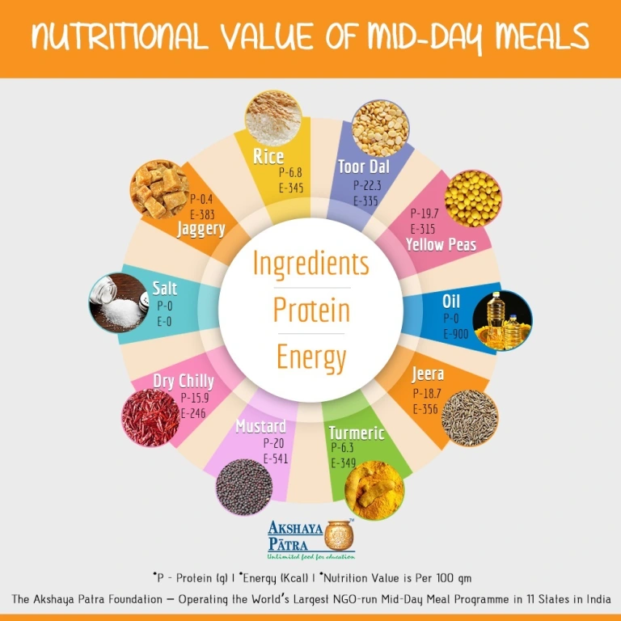

Consumption of body building foods : Pulses were consumed daily by only 15.5

Pulses are consumed by only 15.5 per cent and remaining 84.5 per cent consume the same 4-6 times per week (t/wk). It is observed that 92.7 per cent of children were non-vegetarians and remaining 7.2 percent were vegetarians. A majority (67.2 per cent) of non-vegetarian (NV) children consumed meat and poultry only 1-2 t/w. Occasional consumption was recorded by 17.5 per cent; and 7.9 per cent of children never consumed these foods. Only 7.4 per cent were consuming 2-4 t/wk. Fish were consumed 1-2 t/wk only by 5.9 per cent. A majority (83.5 per cent) consumed occasionally and remaining 10.6 per cent never

consumed fish. Data on egg consumption reveal that about 50 per cent of the children were consuming only 1-2 t/wk and 22.7 and 20.8 per cent respectively consumed 2-4 t/wk and occasionally. Milk and milk products were consumed by 39 per cent daily and 4-6 t/wk by 25.9 per cent. This is followed by 12.8, 12.9 and 9.4 per cent respectively

The Mid Day Meal Guidelines prescribe the following nutritional content to achieve the objectives of the Scheme in the mid-day meal:

| **Items** | **For children of Primary classes** | **For children of Upper Primary classes** |
| --- | --- | --- |
| **A) Nutritional Norms (Per child per day)** | | |
| Calorie | 450 | 700 |
| Protein | 12 gms | 20 gms |
| **B) Food Norms (Per child per day)** | | |
| Food-grains | 100 gms | 150 gms |
| Pulses | 20 gms | 30 gms |
| Vegetables | 50 gms | 75 gms |
| Oil & fat | 5 gms | 7.5 gms |
| Salt & condiments | As per need | As per need |

**CHAPTER 6: RECOMMENDATIONS AND CONCLUSIONS OF THE MINI PROJECT**

**USING Millet BASED NUTRITION:**

In our region, Rayalaseema millets are consumed in good proportion and it is a part of out diet but in mid-day meals mostly millets are avoided and it is primarily a rice-based meal with some pulses and vegetables due to their high prices. In other words, the MDM’s major ingredient is a cereal,

particularly rice and wheat. Given the extent of undernutrition in children, there isscope to improve the nutrient content of MDMs by providing more nutritious food using crops that are locally available and traditionally used. Over the decades, millets have become less and less common in India in terms of both production and consumption, partly because of the limited knowledge on their use in preparing various foods. Lately, these nutritional and drought-resistant properties of millets have drawn the attention of research agencies and product developers globally, increasing the focus on improving millet varieties and enhancing their use in modern processed food products.

The studies revealed that all the millet-based menu items had high acceptability, we can use items like: finger millet idli; little and pearl millet bisi belle bath, Ragi sangati , Jonna Rotta . Studies suggest significant potential for millets to replace or supplement rice in school feeding programs for improved nutritional outcomes of children.

By all the above reasons we can recommend that millet-based meals tend to increase the amount of nutrition provided to children by the current mid-day meal programme.

**CONCLUSION:**

By our mini project we concluded that mid-day meals help in physical and mental growth of children. Lots of people state that these programme helps to give proper nutrition to undernutrition children. In the schools we visited mid-day meals programme is working efficiently and lots of students love their meals.

We also observed by our nutrient analysis that every single day required amount of nutrients are provided in various forms by maintaining both taste and nutrition.s

**Student Self-Evaluation for the Community Service Project**



**Please rate your performance in the following areas:**

**Rating Scale: 1 is lowest and 5 is highest rank**

| **1) Oral communication** | **1** | **2** | **3** | **4** | **5** |
| --- | --- | --- | --- | --- | --- |
| **2) Written communication** | **1** | **2** | **3** | **4** | **5** |
| **3) Proactiveness** | **1** | **2** | **3** | **4** | **5** |
| **4) Interaction ability with community** | **1** | **2** | **3** | **4** | **5** |
| **5) Positive Attitude** | **1** | **2** | **3** | **4** | **5** |
| **6) Self-confidence** | **1** | **2** | **3** | **4** | **5** |
| **7) Ability to learn** | **1** | **2** | **3** | **4** | **5** |
| **8) Work Plan and organization** | **1** | **2** | **3** | **4** | **5** |
| **9) Professionalism** | **1** | **2** | **3** | **4** | **5** |
| **10) Creativity** | **1** | **2** | **3** | **4** | **5** |
| **11) Quality of work done** | **1** | **2** | **3** | **4** | **5** |
| **12) Time Management** | **1** | **2** | **3** | **4** | **5** |
| **13) Understanding the Community** | **1** | **2** | **3** | **4** | **5** |
| **14) Achievement of Desired Outcomes** | **1** | **2** | **3** | **4** | **5** |
| **15) OVERALL PERFORMANCE** | **1** | **2** | **3** | **4** | **5** |

**Date: Signature of the Student**

**Evaluation by the Person in-charge in the Community/Habitation**



**Please rate the student’s performance in the following areas:**

**Please note that your evaluation shall be done independent of the Student’s self-evaluation Rating Scale: 1 is lowest and 5 is highest rank**

| **1) Oral communication** | **1** | **2** | **3** | **4** | **5** |
| --- | --- | --- | --- | --- | --- |
| **2) Written communication** | **1** | **2** | **3** | **4** | **5** |
| **3) Proactiveness** | **1** | **2** | **3** | **4** | **5** |
| **4) Interaction ability with community** | **1** | **2** | **3** | **4** | **5** |
| **5) Positive Attitude** | **1** | **2** | **3** | **4** | **5** |
| **6) Self-confidence** | **1** | **2** | **3** | **4** | **5** |
| **7) Ability to learn** | **1** | **2** | **3** | **4** | **5** |
| **8) Work Plan and organization** | **1** | **2** | **3** | **4** | **5** |
| **9) Professionalism** | **1** | **2** | **3** | **4** | **5** |
| **10) Creativity** | **1** | **2** | **3** | **4** | **5** |
| **11) Quality of work done** | **1** | **2** | **3** | **4** | **5** |
| **12) Time Management** | **1** | **2** | **3** | **4** | **5** |
| **13) Understanding the Community** | **1** | **2** | **3** | **4** | **5** |
| **14) Achievement of Desired Outcomes** | **1** | **2** | **3** | **4** | **5** |
| **15) OVERALL PERFORMANCE** | **1** | **2** | **3** | **4** | **5** |

**Date: Signature of the Supervisor**

**PHOTOS AND VIDEO LINKS**

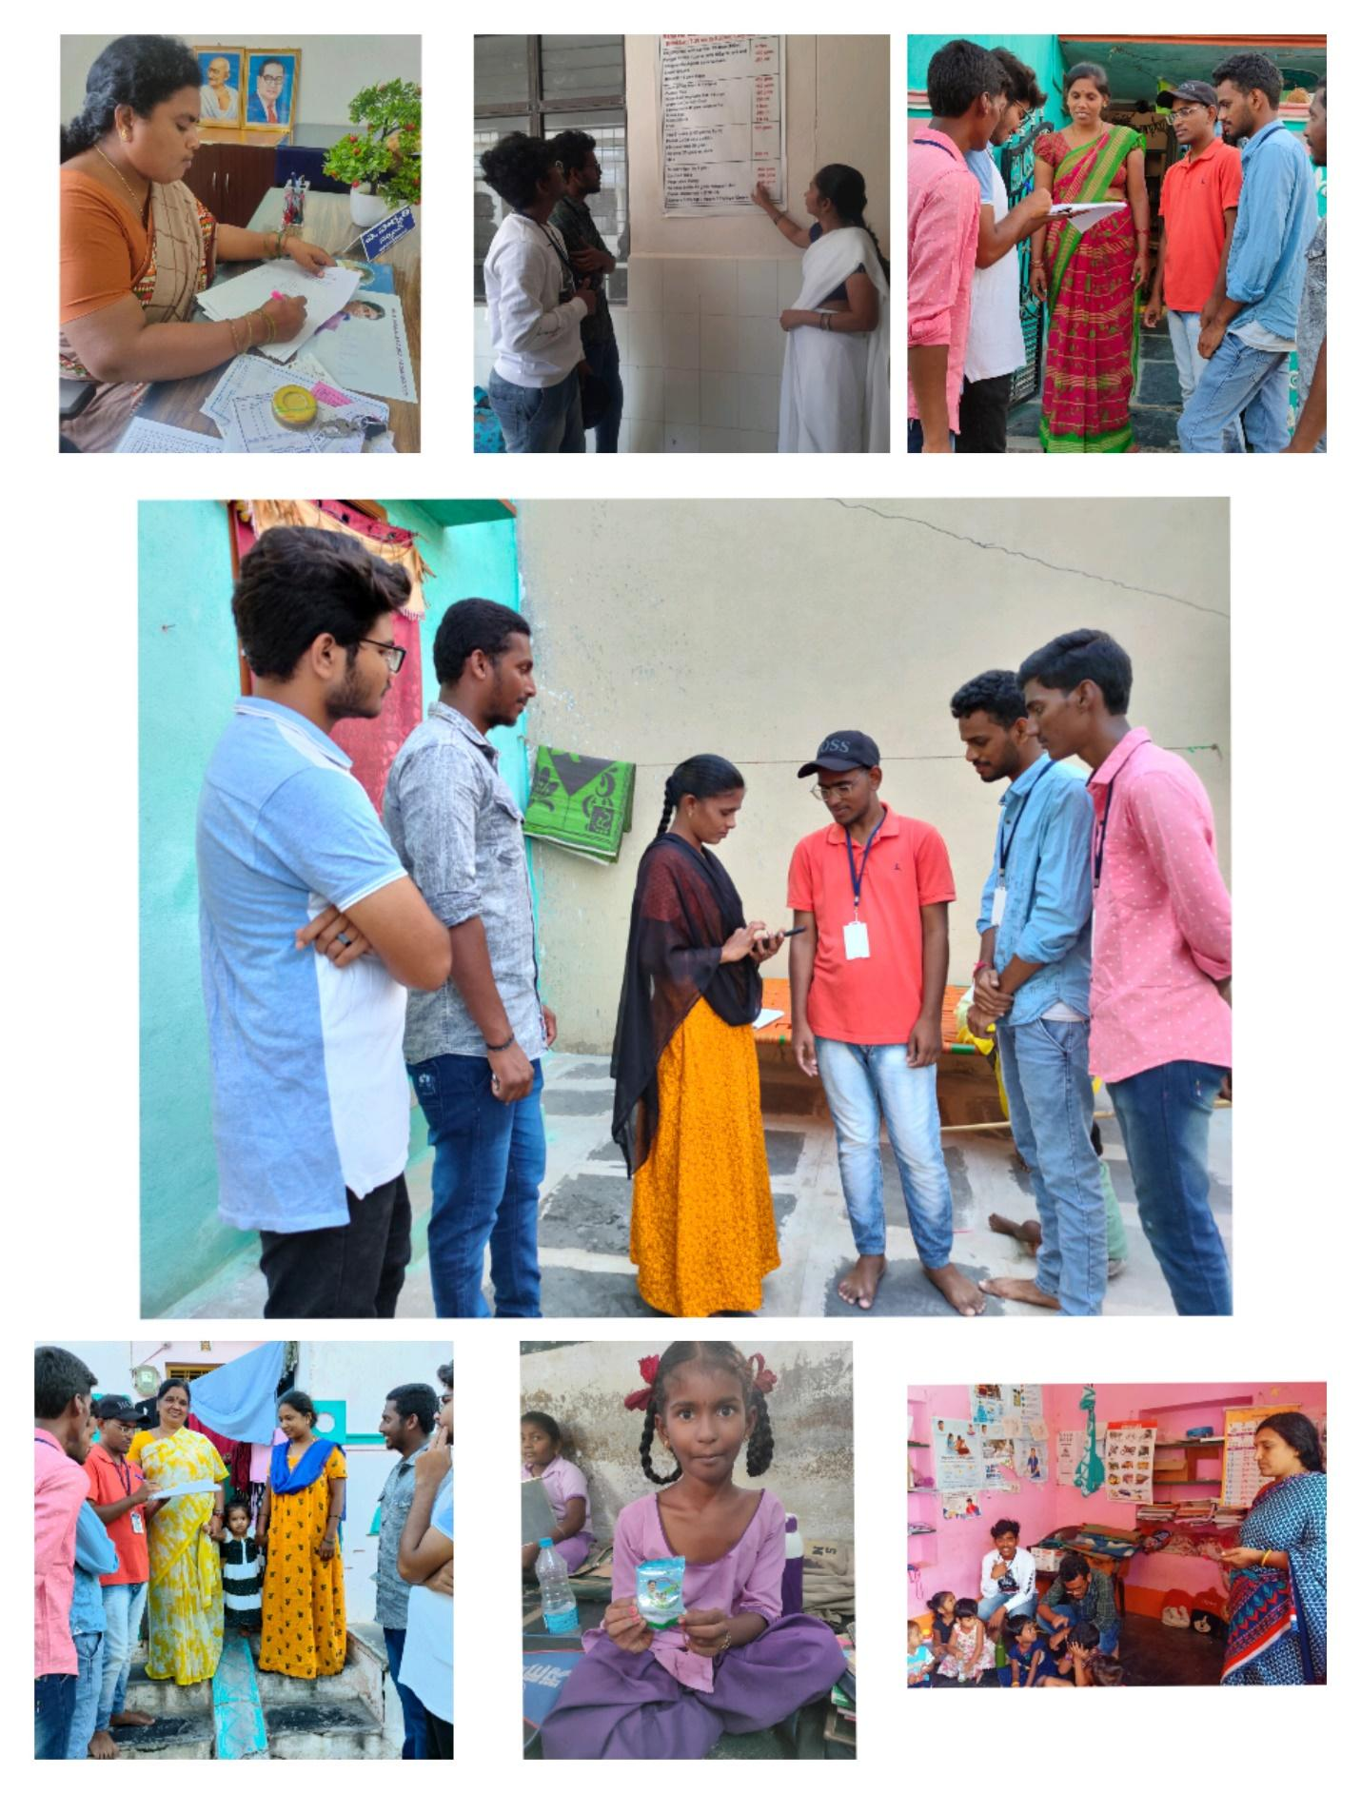Week 1:

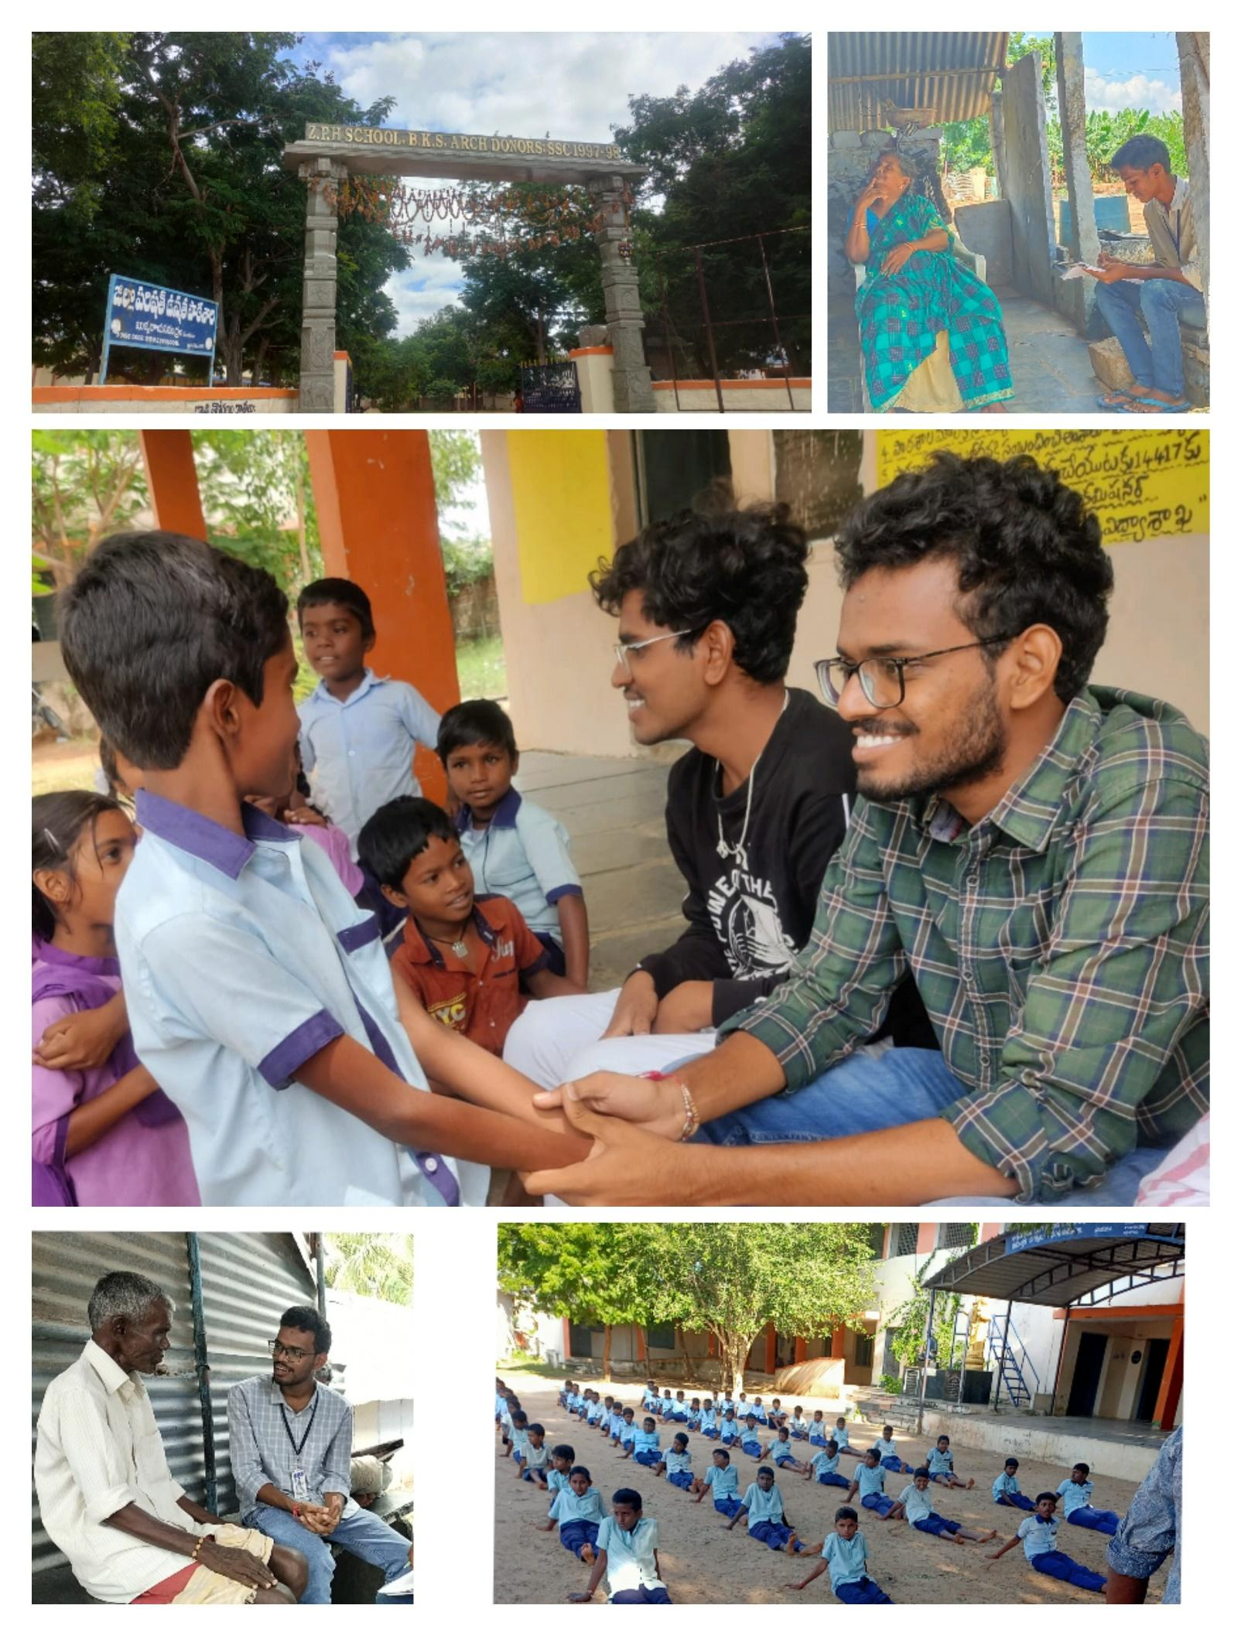



WEEK-2

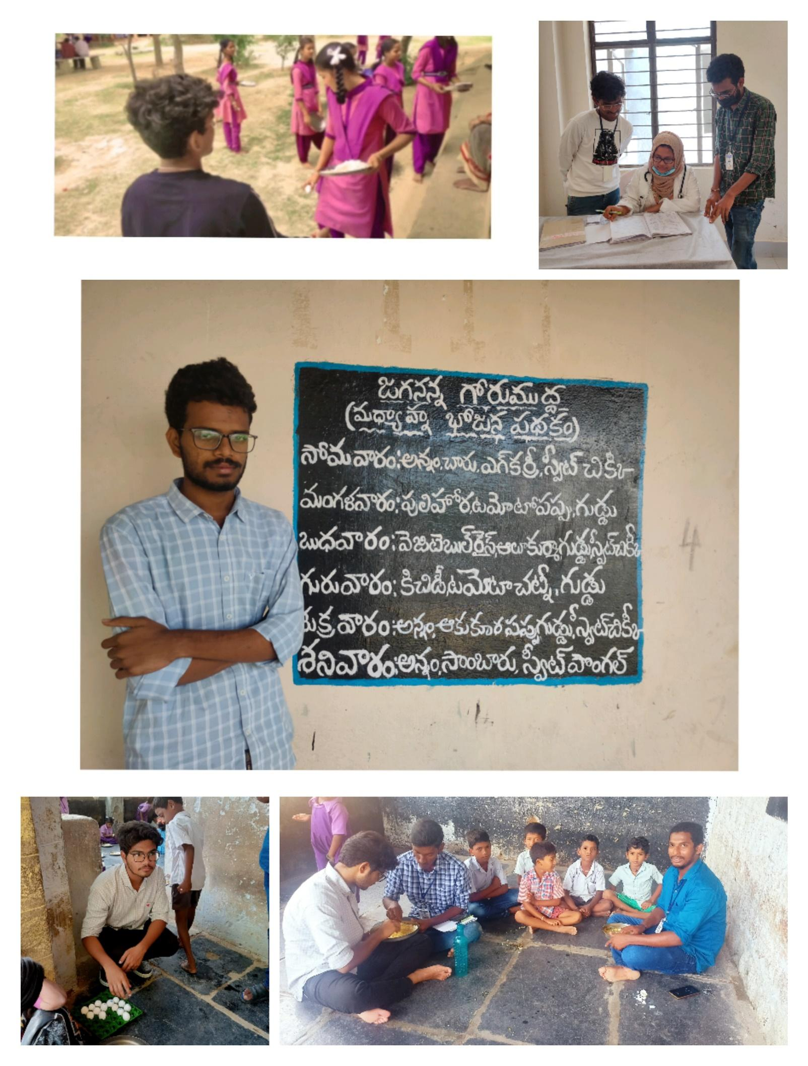

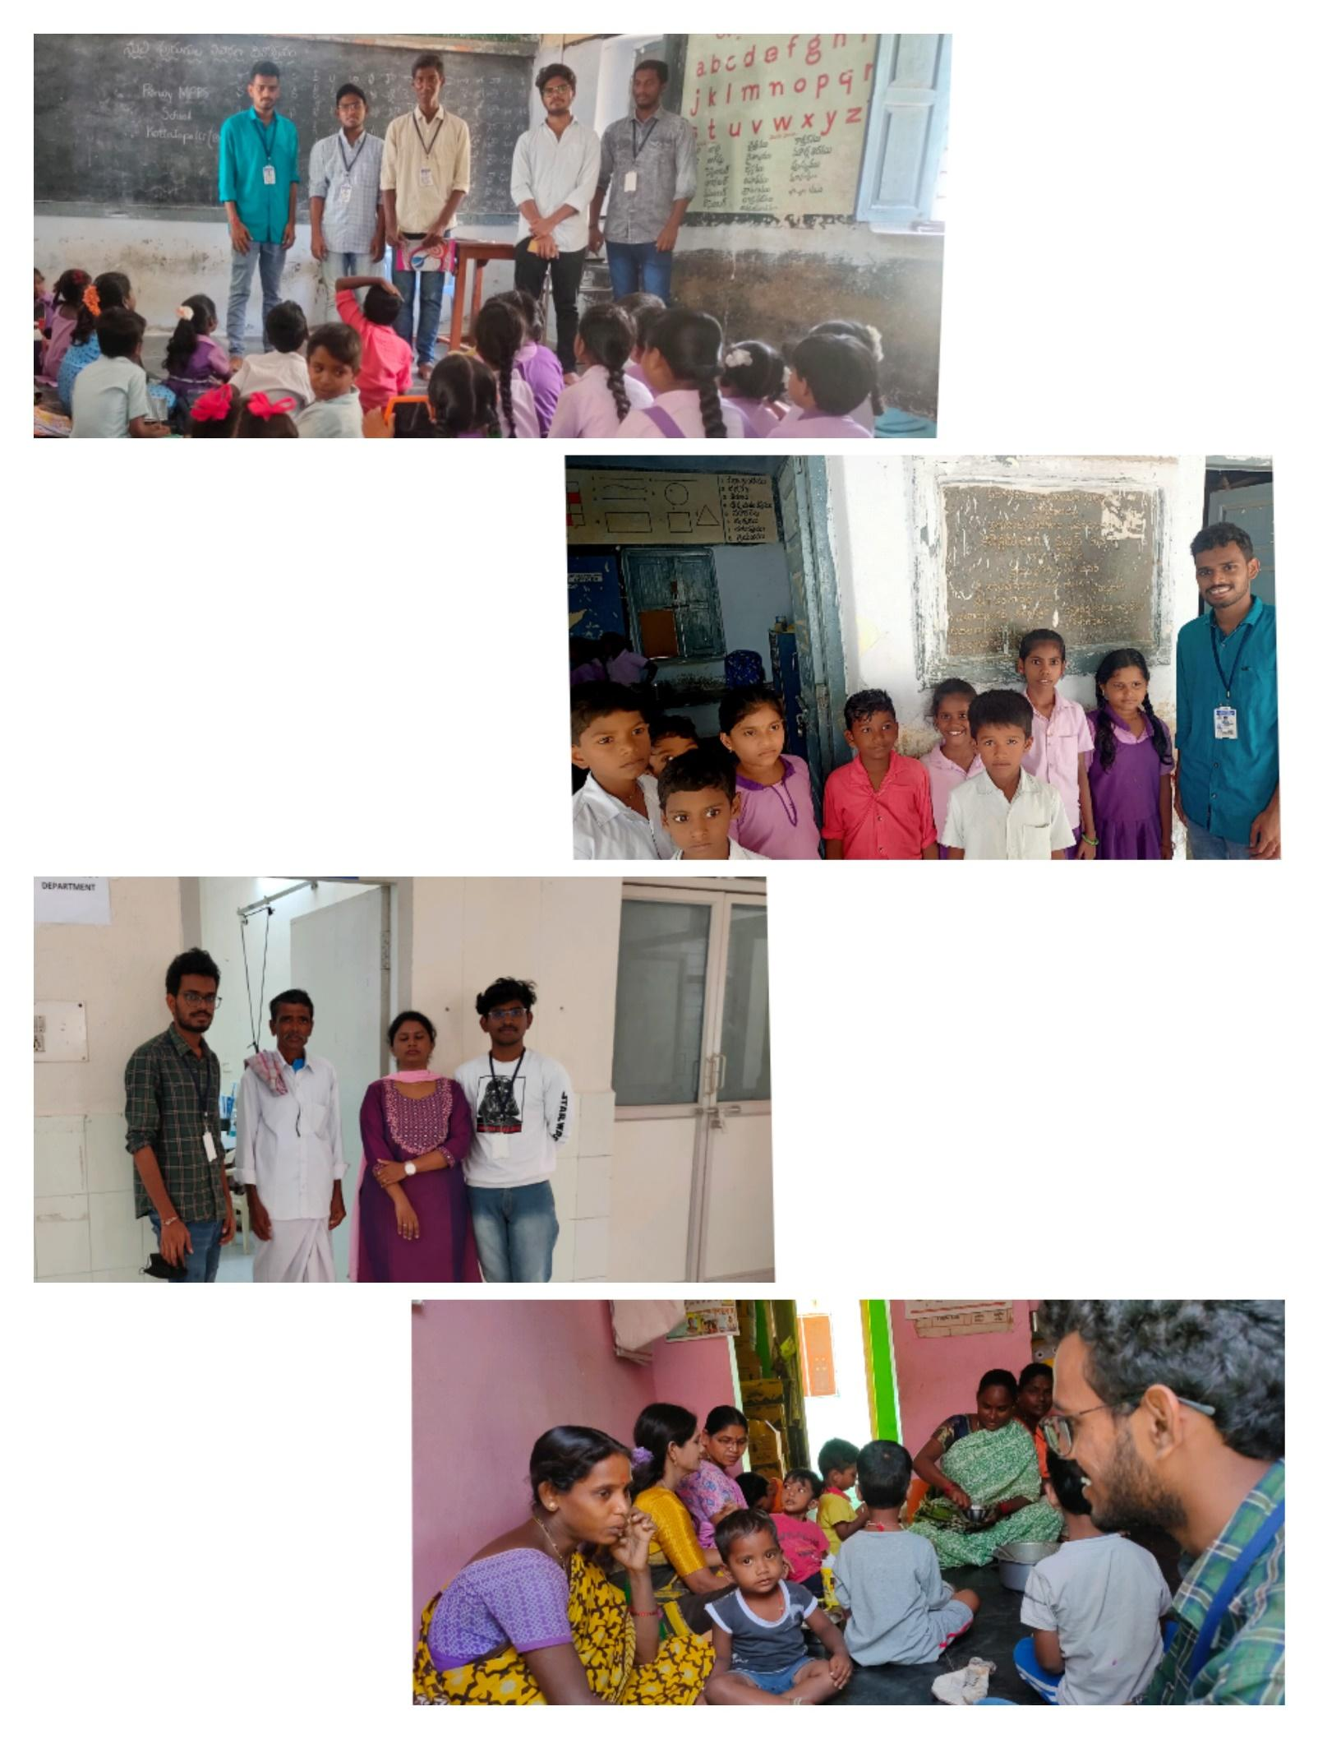

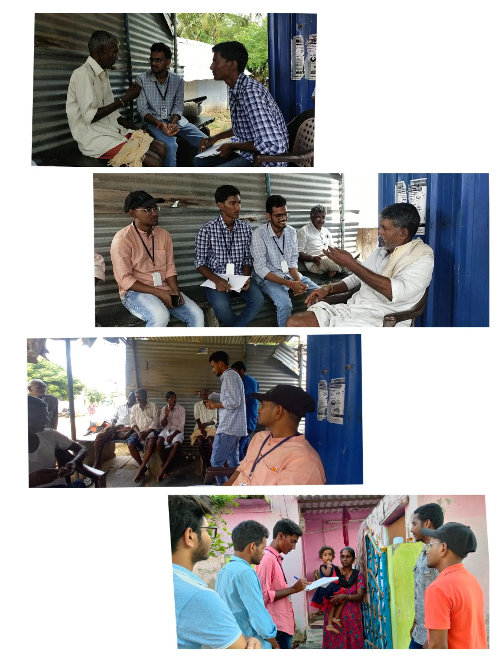

WEEK-3

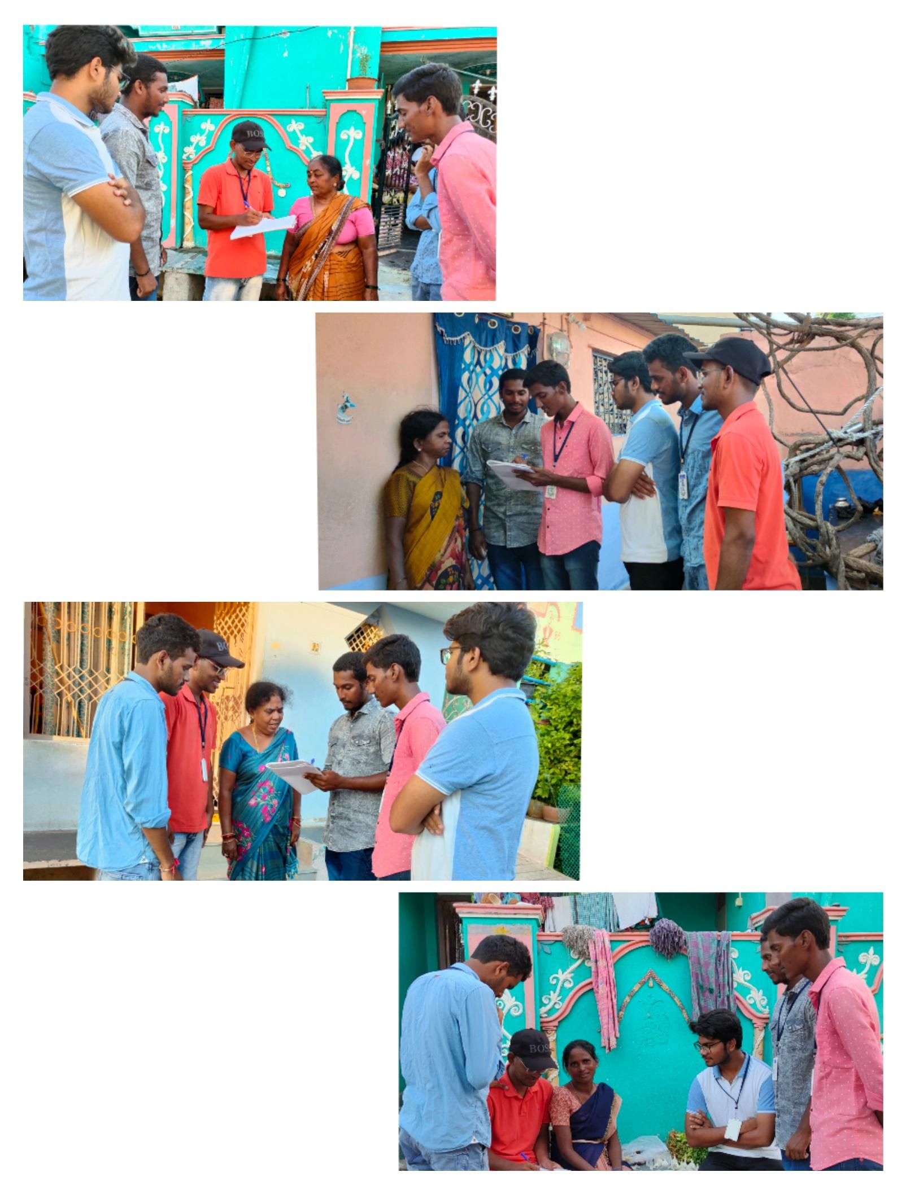

WEEK-4:

